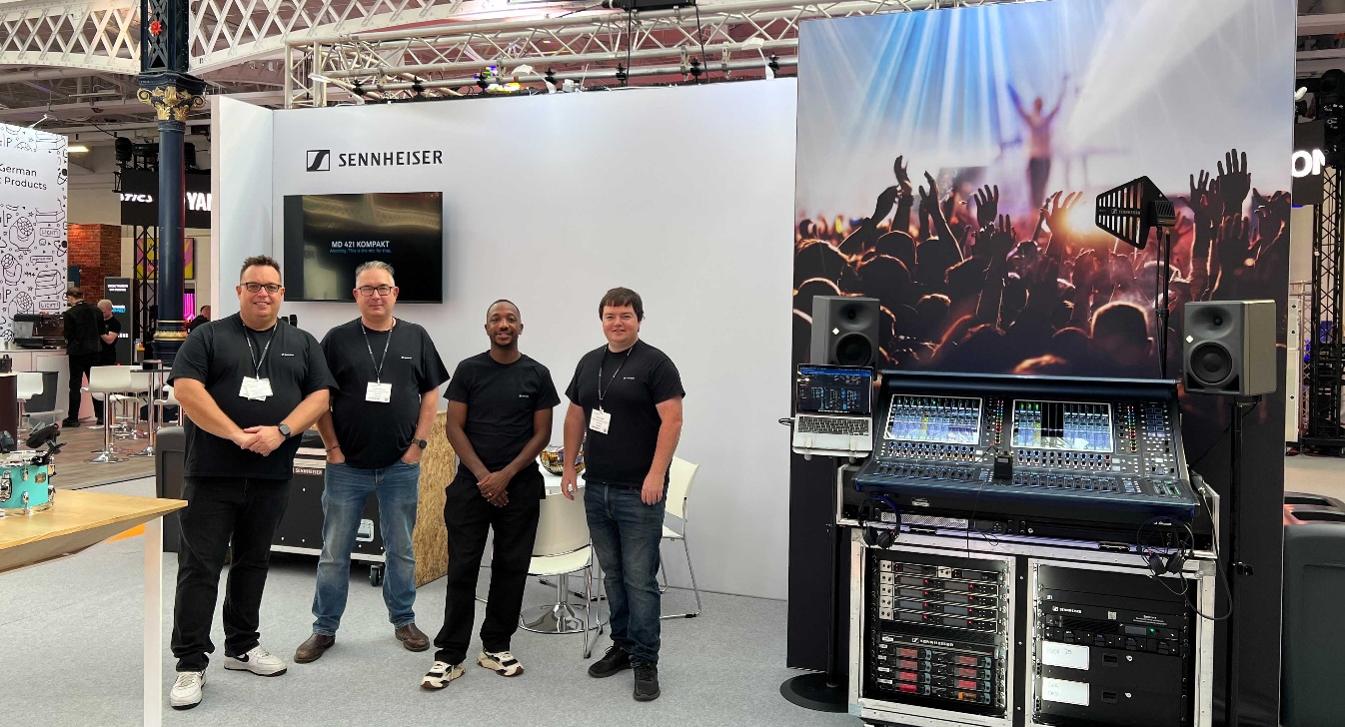

Sennheiser and Neumann bring their latest professional audio solutions to PLASA Show London

An extensive range of Sennheiser and Neumann innovations take centre stage on Stand D6

Marlow, UK, 27 August 2026 – Sennheiser and Neumann are delighted to return to the PLASA Show 2026, where visitors can experience the latest innovations in professional audio on Stand D6. The team will be on hand throughout the show to provide live demonstrations, answer technical questions, and discuss solutions for a wide range of live sound, touring, theatre and broadcast applications.

Spectera handheld shipping mid-September
Visitors will have the opportunity to explore the Spectera wideband, bidirectional digital wireless ecosystem, including the eagerly awaited Spectera SKM handheld transmitter, which will start shipping from mid-September.

The Spectera SKM handheld will start shipping from mid-September | 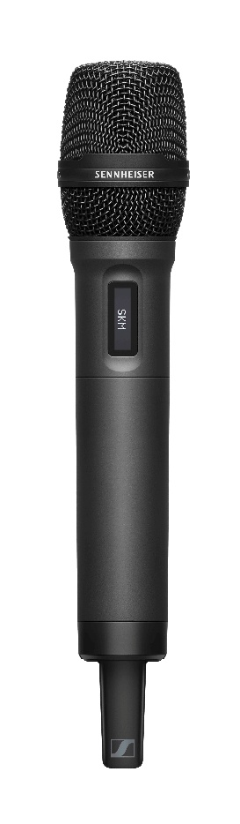

Also on show are Evolution Wireless Digital systems, Sennheiser stage microphones and professional Sennheiser headphones, including the latest HD 480 PRO, Sennheiser’s top-of-the-range closed-back headphones for studio and live environments.

Partner SoundBase reveals major updates
SoundBase will demonstrate its brand-agnostic RF planning app, whose full Spectera integration makes it the world’s first RF management application built for both narrowband and wideband systems across multiple manufacturers. The exciting Remote View feature is another SoundBase highlight, letting users generate shareable links with customisable views for all members of a production.

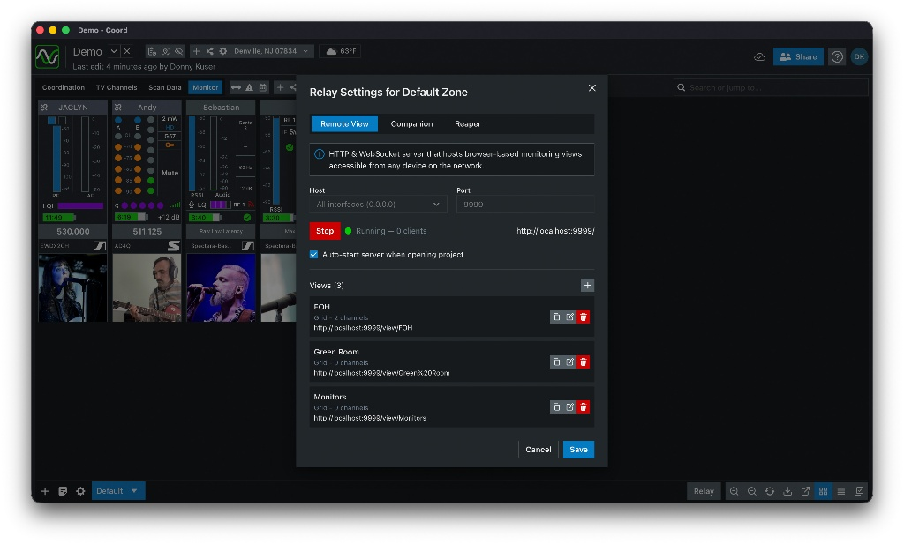 | With SoundBase’s Remote View tool, you can share wireless hardware telemetry across a production without running duplicate instances of software

Until today, wireless operators who needed access to hardware data across a production or show site all had to download the same monitoring software onto their devices to be able to see what was going on, creating a lot of network traffic. Remote View addresses this issue and streamlines the workflow by acting as a built-in web server.

“Remote View is a much smarter way to share wireless hardware telemetry across multiple endpoints without running duplicate instances of software,” says Donny Kuser, co-founder of SoundBase. “By reducing connections and network traffic, your control network stays efficient and your gear stays responsive.”

Neumann solutions for stage and studio
Neumann will complement the PLASA Show London offering by showcasing a selection of its live performance, recording and studio monitor solutions. Visitors will be able to experience Neumann’s live microphone portfolio alongside its KH studio monitor range, the MT 48 audio interface, and NDH professional headphones.

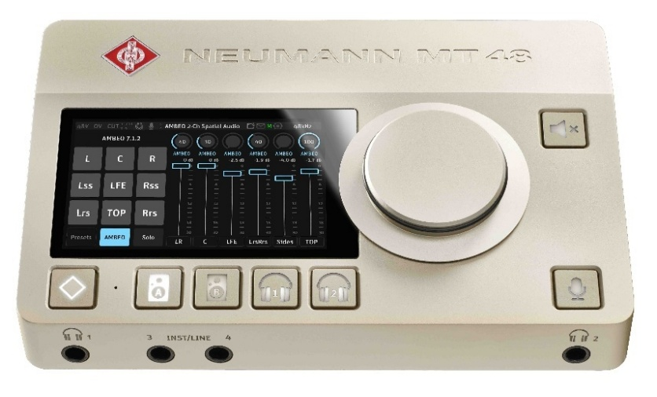 | The Neumann MT 48 audio interface

“We’re really looking forward to being back at PLASA Show London and welcoming customers, partners and friends to our stand,” says Kevin Gwyther-Brown, Sennheiser’s Manager Business Development, Live Performance. “It’s always a fantastic opportunity to connect with the professional audio community, share what we’ve been working on and give visitors the chance to experience our latest innovations first-hand. There will be plenty to discover on Stand D6, so make sure you come and see us!”

Visitors can meet the team on Stand D6 at the PLASA Show 2026, taking place at Olympia London from 6–8 September 2026.

(Ends)

The images accompanying this media release can be downloaded here.

About the Sennheiser Group
Building the future of audio and creating unique sound experiences for our customers - this is the aspiration that unites the employees of the Sennheiser Group worldwide. The independent family-owned company Sennheiser was founded in 1945. Today, it is managed in the third generation by Dr Andreas Sennheiser, and is one of the leading manufacturers in the field of professional audio technology.

Local Press Contacts
Stephanie Schmidt Sarah James
stephanie.schmidt@sennheiser.com sarahj@gasolinemedia.com
+49 (5130) 600 – 1275 +44 (0)7702 421635

